Sire CLEARCREEK BONAVENTURE DUST IN THE WIND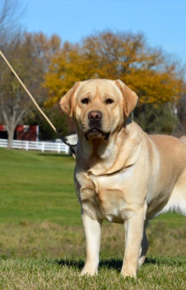 | Sire CH. HYSPIRE MARITIME EVERYTHING YOU ALWAYS WANTED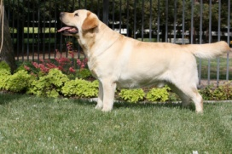 | Sire BISS GCH. SURE SHOT HYSPIRE IMPRSSIVE, WC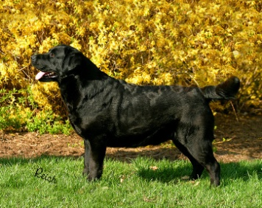 | Sire CH. WINDFALL’S PIPE MAJOR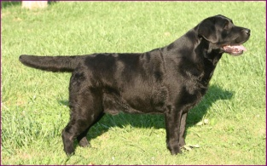
 |  |  | Dam CH. JANROD’S TAMMY WHYNOT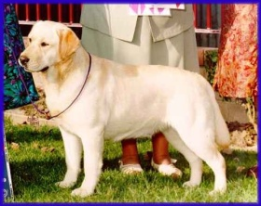
 |  | Dam CH. MARITIME FORECAST MATILDE, WC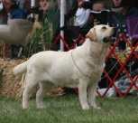 | Sire BISS CH. HYSPIRE HOT TO TROT, RN, JH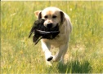
 |  |  | Dam MARITIME HYSPIRE NO DOUBT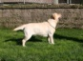
 | Dam AM/CAN/ENG SH. CH. CLEARCREEK BONAVENTURE WINDJAMMER, JH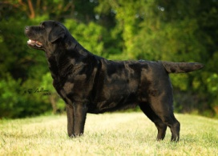 | Sire CH. BONAVENTURE’S CLIPPER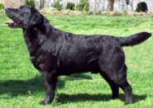 | Sire CH. GLENGARY LUBBERLINE SCHOONER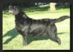
 |  |  | Dam BREEZEWOOD GLENGARY WINDFALL
 |  | Dam CLEARCREEK BONAVENTURE ASPEN’S RUN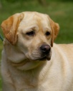 | Sire BISS CH. LENCHES TEDDY BEAR
 |  |  | Dam CH. BONAVENTURE’S GLORY BOUND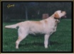
Dam CH. OBETHELS & CHASE’S PAY THE PIPER, CA, BCAT, DCAT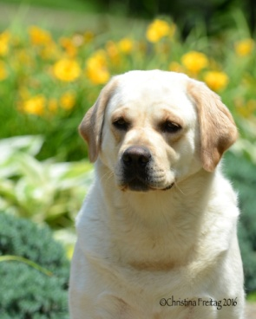 | Sire CH. SHANNON’S ABSOLUT WHITE RUSSIAN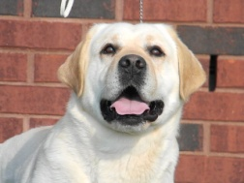 | Sire CH. TULLAMORES TOBLERONE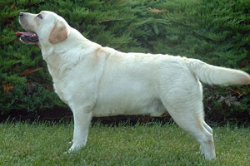 | Sire BISS GCH. CH. SURE SHOT HYSPIRE IMPRESSIVE, WC
 |  |  | Dam CH. TULLAMORES MIKIMOTO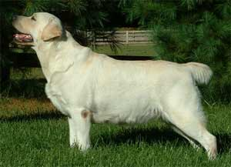
 |  | Dam CH. SHANNON’S SALT AND PEPPAR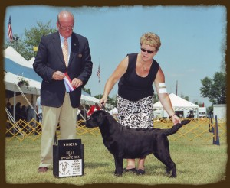 | Sire CH. SHANNON’S ABSOLUT PEPPAR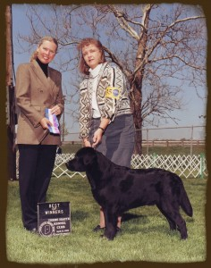
 |  |  | Dam CH. SHANNON’S SISTER CHRISTIAN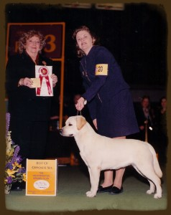
 | Dam CHASE’S & OBETHEL’S SPRING TIME DAISY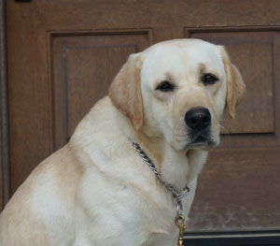 | Sire O’BETHELS SPRING TIME CUB | Sire BISS AM/CAN CH. CLARION’S BAD AS I WANNA BE, CD, AM/CAN MH, WCX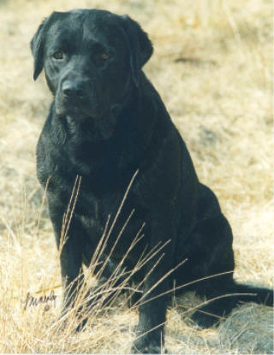
 |  |  | Dam CH. CHASE’S SPRING FEVER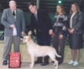
 |  | Dam CHASE’S GUARDIAN ANGEL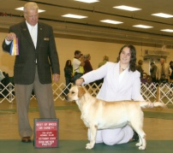 | Sire JALIN’S CHI-TOWN SYNDICATE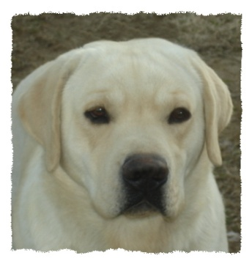
 |  |  | Dam CHASE’S FIELD OF DREAMS